**Name:** V Venkata Sri Prasad

**Batch:** Data Engineering

**Date:** 13/02/2024 – (Day 19)

Topics:

Visualization of data using Azure Databricks:

Display():1

Display keyword used to initiate the visualization of data

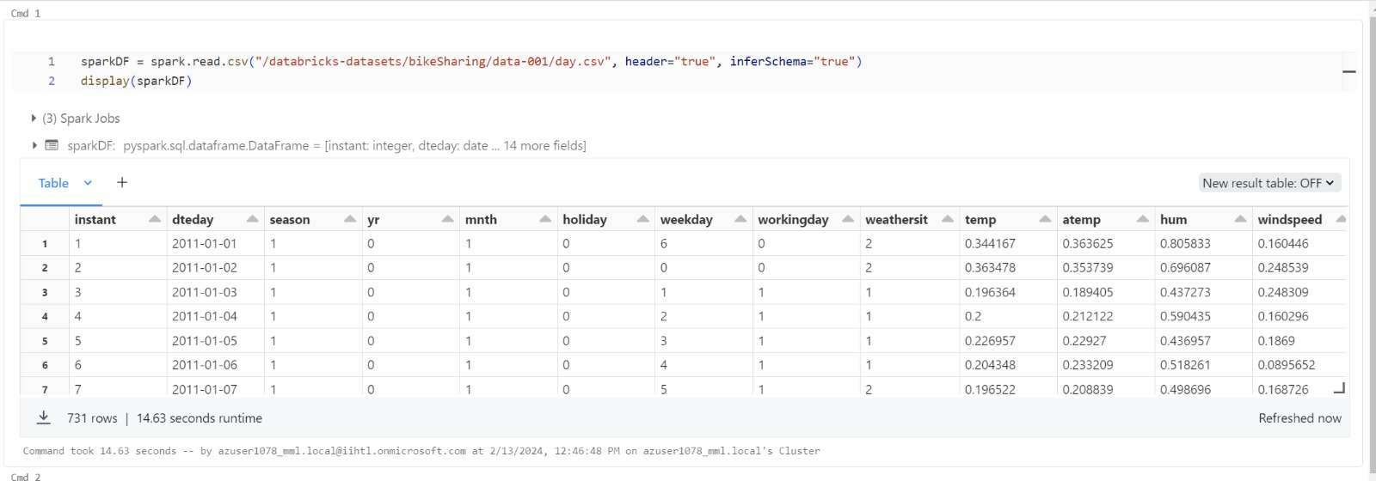

Click on visualization button

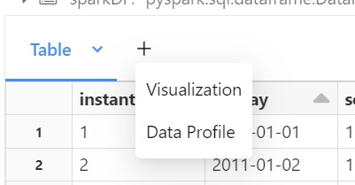

We can select the graph type, columns names and attributes to b e displayed 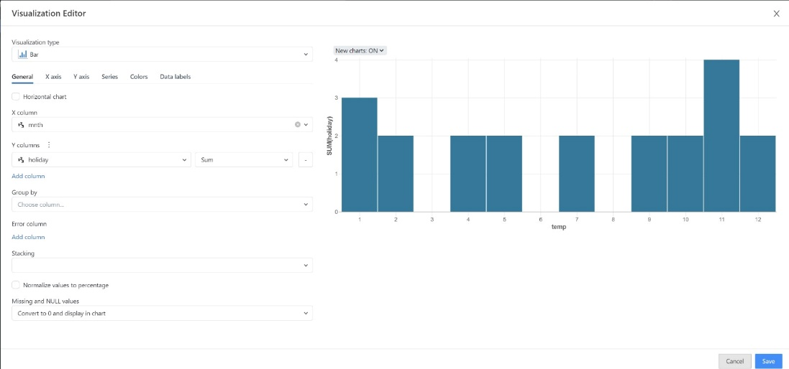

We can change the color in colors section

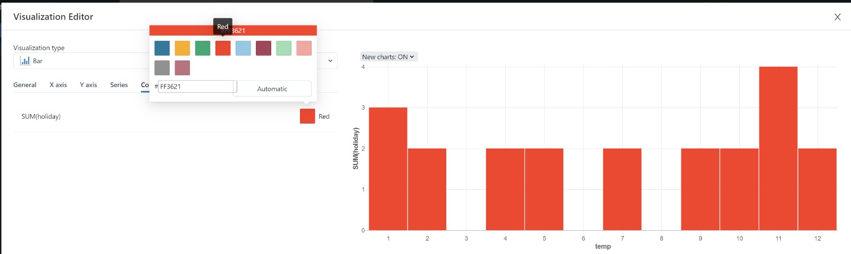

Data Profile

In Databricks, the display keyword is used to generate visualizations and summary statistics for data, providing a concise profile of its characteristics, enabling quick insights and analysis.

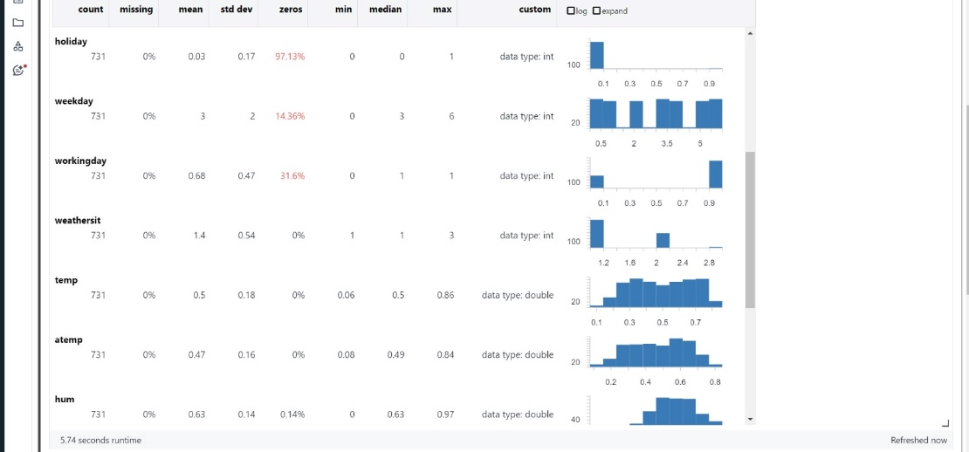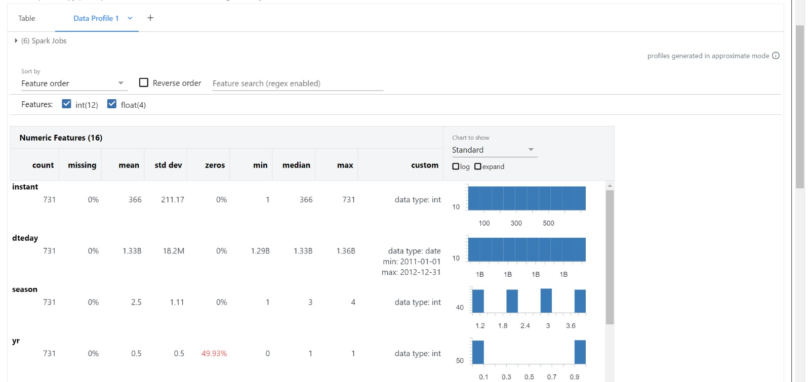

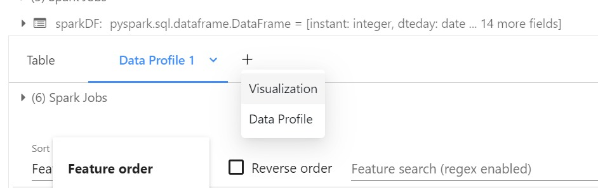

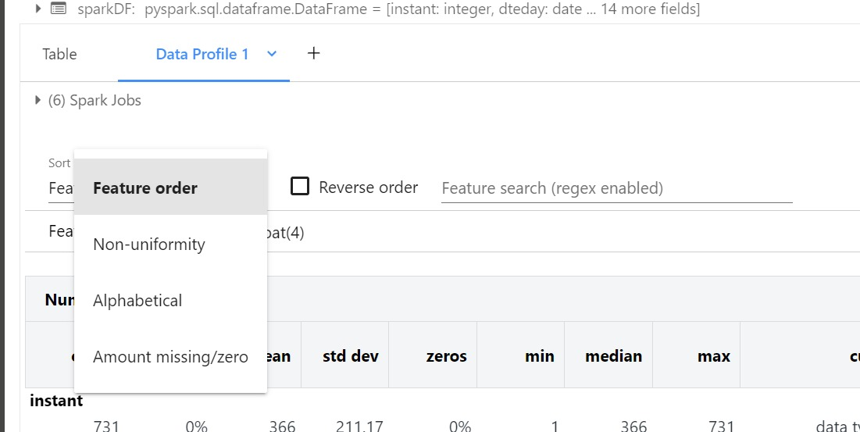

Notes:

